TASK 6
Final Data Science Capstone Project
Predicting diamond prices from their physical characteristics
Data Science Internship Report
Submitted by: [Your Full Name]
November 2026

1. Problem definition

1.1 Problem statement
Diamond prices are driven by a mix of size, cut, colour and clarity (the "four Cs"), and the relationships are not obvious: a larger stone costs more, but a better-cut stone is not necessarily more expensive in raw data. The problem I chose is to predict the retail price of a diamond from its measurable attributes, and to explain which attributes matter most.

1.2 Objectives and scope
- Build a regression model that predicts price accurately on unseen diamonds.
- Compare simple and complex models honestly, using the same split and metrics.
- Explain results, errors and limitations in plain language.
Out of scope: forecasting how prices change over time, or pricing diamonds with attributes the dataset does not contain (certification, fluorescence, origin).

1.3 Success criteria
A model is useful if it clearly beats a naive "always predict the average price" baseline, generalises (cross-validated score close to test score), and has errors small enough to be relevant to a buyer or seller, which I defined as a typical error under about 10% of the price.

2. Data collection and preparation

2.1 Source
I used the public diamonds dataset from the seaborn-data repository: 53,940 diamonds with 10 columns: price in US dollars, carat (weight), cut, colour, clarity, depth and table percentages, and the dimensions x, y and z in millimetres.

2.2 Quality checks and cleaning
Issue | Count | Action
Missing values | 0 | None needed
Duplicate rows | 146 | Removed
Dimensions equal to 0 (physically impossible) | 20 | Removed
Implausibly large y or z (over 20 mm) | 3 | Removed as data-entry errors

After cleaning, 53,772 rows remained, about 0.3% of the original data. I kept other unusual values, such as very expensive stones, because they are real.

2.3 Feature engineering
- Log of price as the target. Price is right-skewed (skewness 1.62) with a long tail of expensive stones; its log is far more symmetric, which suits regression. Predictions are converted back to dollars before computing error metrics.
- Ordinal encoding for cut, colour and clarity using their true quality order (for example Fair to Ideal), so the model sees that Ideal is better than Good.
- Volume (x × y × z) as a proxy for physical size, and a recalculated depth percentage to cross-check the supplied one.
- Scaling of numeric columns, handled inside a scikit-learn Pipeline so nothing is learned from the test set.
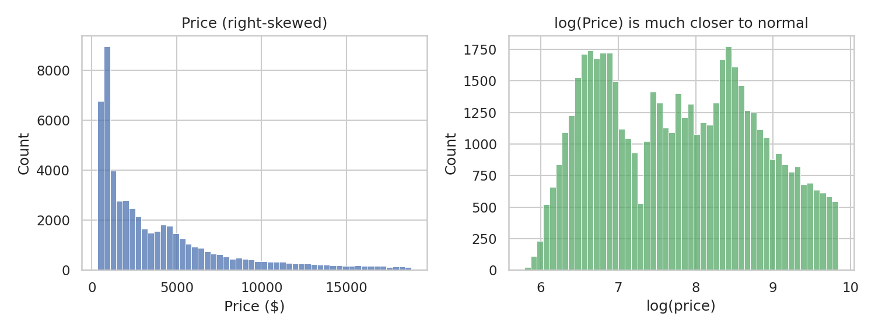
Figure 1. Raw price (left) is heavily skewed; log price (right) is much more balanced.

3. Exploratory analysis
Carat has the strongest relationship with price (correlation 0.922); the three dimensions are also highly correlated with price (about 0.887) and, as expected, with each other. Depth barely matters on its own (-0.011).
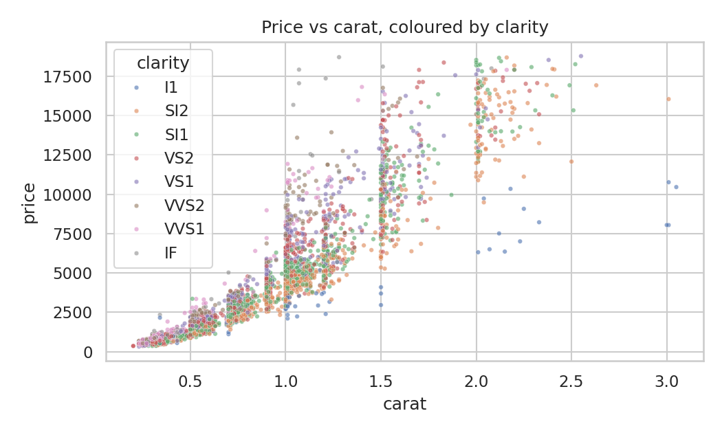
Figure 2. Price rises steeply with carat, and the spread widens for larger stones.
The scatter plot shows two features that matter for modelling: the relationship is curved, not straight, and the variation in price grows with size. Both support using a log target.

A counter-intuitive result
Median price by cut is $1,813 for Ideal but $3,178 for Premium and $3,282 for Fair. The best cut is the cheapest! The same oddity shows up for clarity (the top grade IF has a median of $1,080 against $4,071 for SI2) and colour (D, the best, at $1,842 vs J, the worst, at $4,234). This is a confounding effect: higher-quality stones in this data tend to be smaller, and size dominates price. A model that includes carat can separate the two effects; a simple group average cannot.
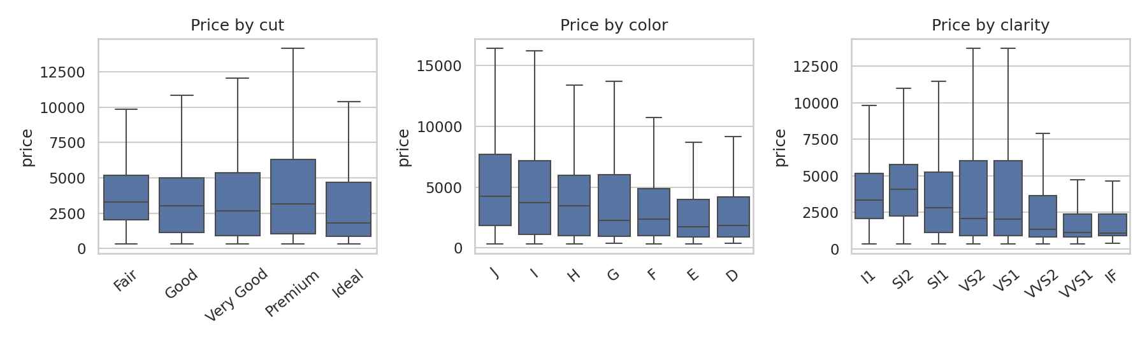
Figure 3. Price by cut, colour and clarity without controlling for size.

4. Modelling approach
- Split: 80% training (43,017 diamonds) and 20% test (10,755), with a fixed random seed.
- Baseline: always predicting the average log-price gives a test error of about $2,772 on average.
- Models compared: linear regression, ridge regression, random forest and gradient boosting, all inside the same preprocessing pipeline.
- Metrics: R² (share of variation explained), MAE (average dollar error), RMSE (penalises large errors) and MAPE (average percentage error), all computed on the dollar scale on the held-out test set.

5. Results
Model | R² (log scale) | MAE ($) | RMSE ($) | MAPE (%) | Training time (s)
Linear Regression | 0.9794 | 440 | 834 | 11.3 | 0
Ridge Regression | 0.9794 | 440 | 834 | 11.3 | 0
Random Forest | 0.9918 | 263 | 521 | 6.3 | 24.8
Gradient Boosting | 0.9918 | 269 | 528 | 6.5 | 1

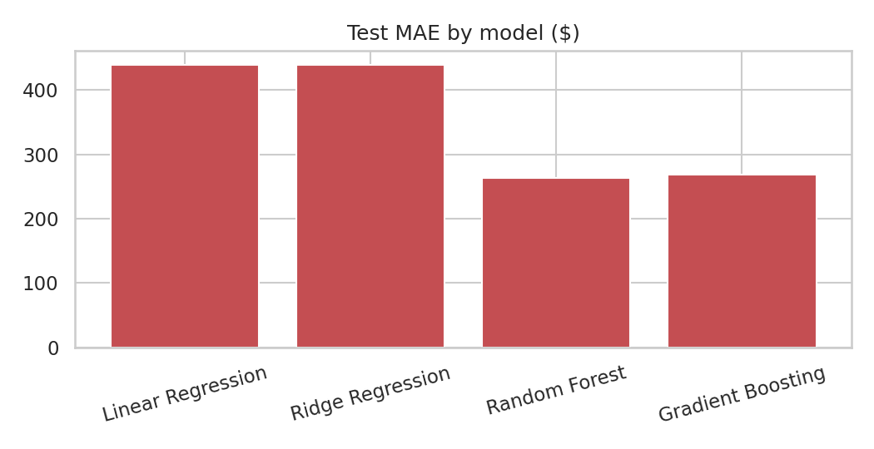
Figure 4. Test MAE by model.
All models are far better than the baseline (average error around $2,772). The two tree-based models are clearly better than the linear ones, cutting the average error from about $440 to about $263, because they can capture the curved, interacting relationships between size and quality. Random forest and gradient boosting are essentially tied: the differences are small enough to be noise. The practical difference is speed: gradient boosting trained in about 1 second versus 24.8 seconds for the forest, so I would choose gradient boosting if the model had to be retrained often.
For the best-scoring model, random forest, five-fold cross-validation on the training data gave R² = 0.9921 (± 0.0003), very close to the test score of 0.9918. That consistency suggests the model is not overfitted to a lucky split.
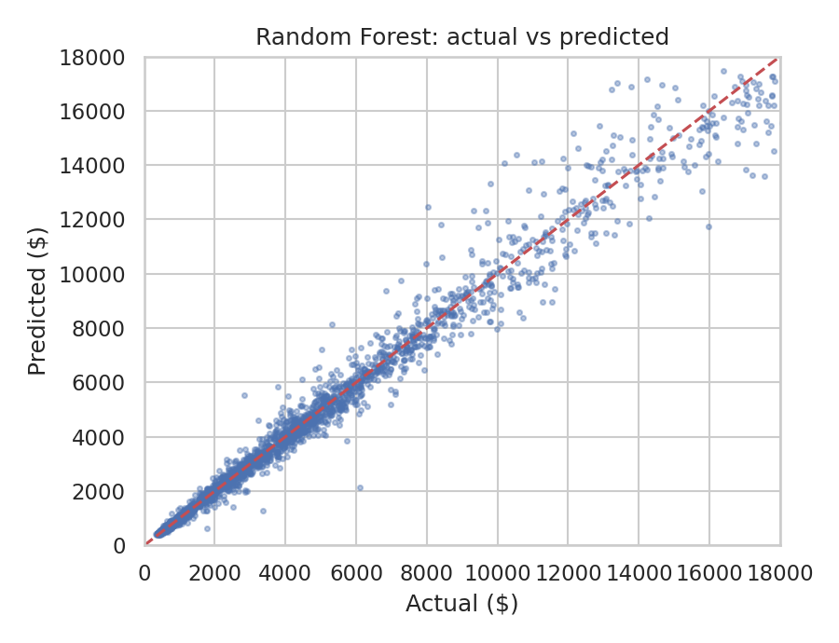
Figure 5. Actual versus predicted price on the test set; the dashed line is perfect prediction.

6. Error analysis and limitations

6.1 Where the model is wrong
The median error is about 4.4% of the price, and the mean percentage error is 6.3%, under my 10% success target. Errors are roughly balanced: 50.9% of predictions fall below the true price, so there is no strong systematic bias towards over- or under-pricing.
True price band ($) | Avg % error | Avg $ error
0 to 1000 | 5.5% | $38.1
1000 to 2500 | 6.1% | $102.3
2500 to 5000 | 7.1% | $260.4
5000 to 10000 | 6.8% | $477.8
10000 to 20000 | 6.9% | $935.7

Percentage error is steady across price bands (roughly 5% to 7%), but dollar error grows from about $38 for the cheapest stones to about $936 for the most expensive. A model that is "6% off" on a $15,000 diamond is still off by around $900, which could matter in practice, so a buyer of high-value stones should treat predictions as a rough guide.

6.2 Which features matter
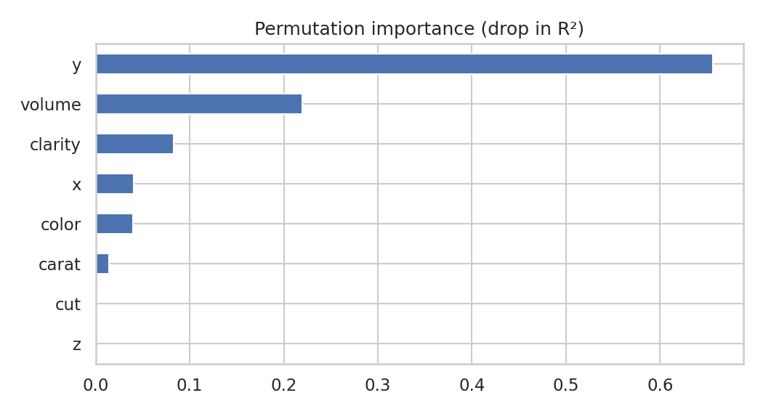
Figure 6. Permutation importance of each feature on the test set.
Permutation importance (how much accuracy drops when a feature is shuffled) ranks y (0.6558), volume (0.2197) and clarity (0.0832) at the top, followed by x, colour and carat. I want to be careful here: x, y, z, volume and carat all measure essentially the same thing, size, so the model can use them interchangeably and the importance gets spread across them in an arbitrary way. The sensible conclusion is that size, as a group, is the main driver, followed by clarity and colour, and not that the y dimension itself is special.

6.3 Limitations
- The data is a single snapshot of one market; prices change with time and region, so the model would need refreshing before real use.
- Important price factors are missing: certification, fluorescence, polish and symmetry, and the seller.
- Very large stones are rare in the data, so predictions there are less certain.
- Interpretation by feature importance is limited by correlated features, as explained above.

7. Insights and recommendations
- Size is the foundation of price. For any valuation, carat or volume should be the first input, with colour and clarity adjusting from there.
- Do not compare quality grades in isolation. Raw averages make the best cut look cheapest; compare diamonds of similar weight.
- A tree-based model is worth using here: it cuts the dollar error of linear regression by about 40% in this data. Gradient boosting offers the same accuracy with much faster training.
- Use predictions as a guide, not a quote. Typical error is about 4% to 6%, but can reach hundreds of dollars on expensive stones; a human appraisal should confirm high-value decisions.
- For a business: use the model to flag listings priced far above or below the prediction for review, rather than to set prices automatically.

8. Future scope
- Tune hyperparameters with a proper search and compare with additional models.
- Predict price ranges (for example with quantile regression) instead of one number.
- Add more features, such as certification data, and test on newer price data.
- Deploy as a simple web app where a user enters carat, cut, colour and clarity and gets an estimated price range.

9. Presentation outline
The accompanying presentation follows this structure, with one idea per slide: (1) problem and why it matters, (2) the data and how I cleaned it, (3) the cut paradox, (4) modelling approach, (5) results table and chart, (6) where the model fails, (7) recommendations, (8) limitations and next steps.

10. Conclusion
The capstone brought together everything from the earlier tasks: defining a problem, preparing data, engineering features, comparing models fairly, and reporting results with their weaknesses. The final model explains about 99.2% of variation in log price and is typically within a few percent of the true value. Equally important was understanding why it works and where it should not be trusted. Code is in scripts/task6_capstone_diamonds.py in the GitHub repository.

